**WebServices**

[EditCandidateEducationalDetails](http://103.230.103.142/jobportalapp/job.asmx?op=EditCandidatePersonalDetails)

[EditCandidatePersonalDetails](http://103.230.103.142/jobportalapp/job.asmx?op=EditCandidatePersonalDetails)

SaveCandidate

Password

Get Branch

Get Course

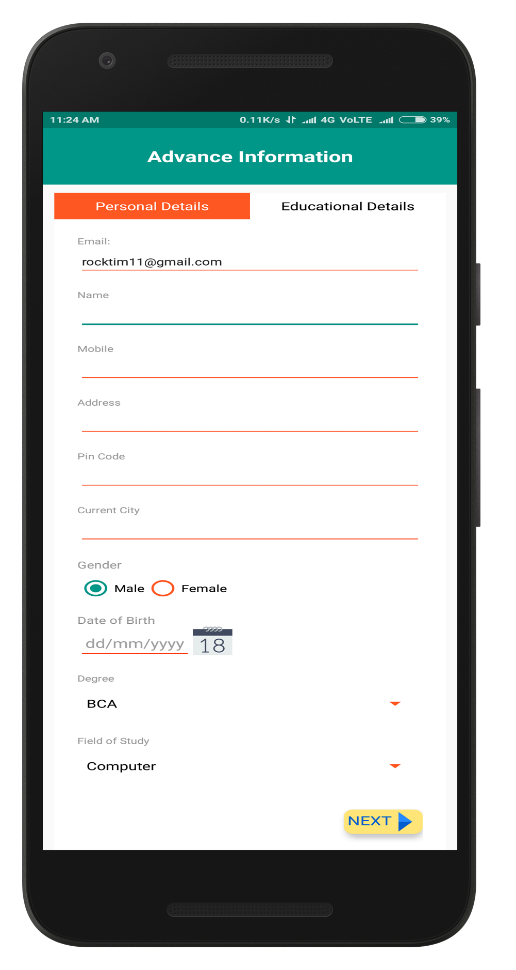

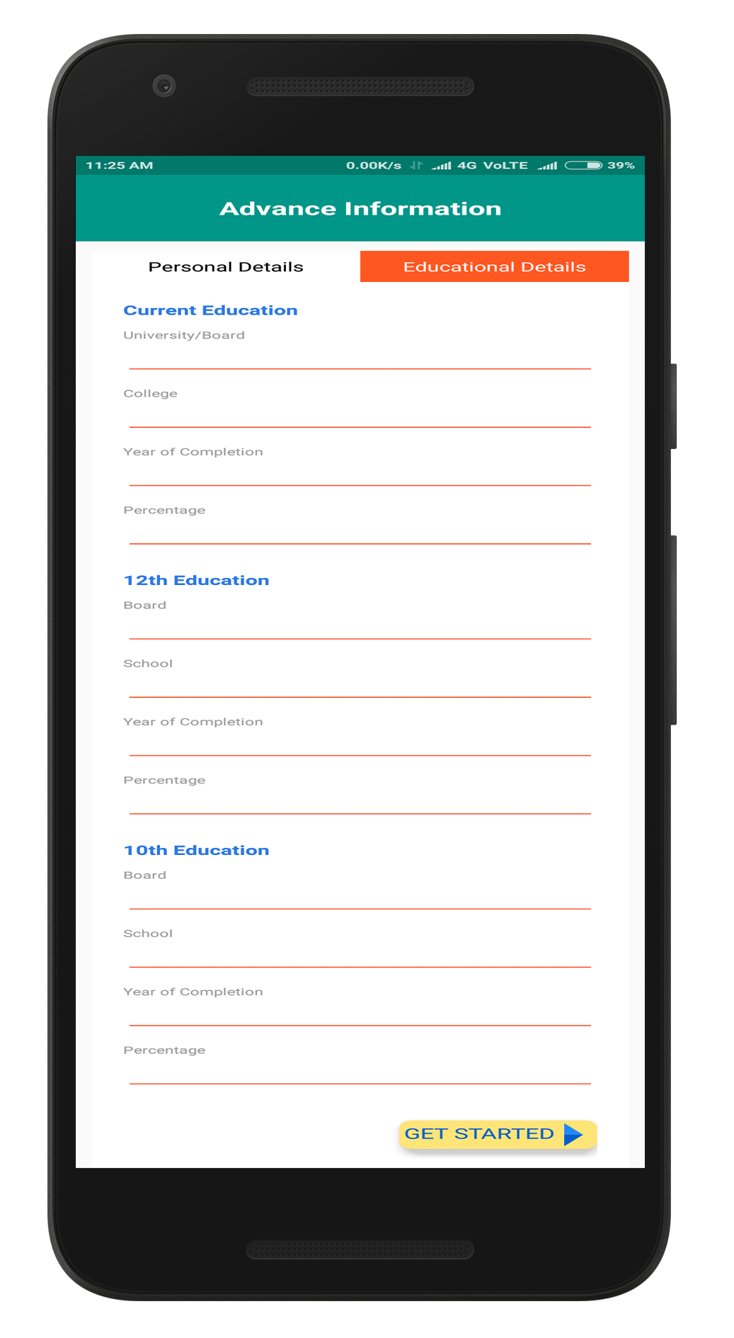

Click on Signup

Email ID and Password is

passed to next intent

Confirm Password

Create a password

Minimum 8 character.

Enter Valid Email ID

**3.**

**2.**

**1.**

Click on Signup

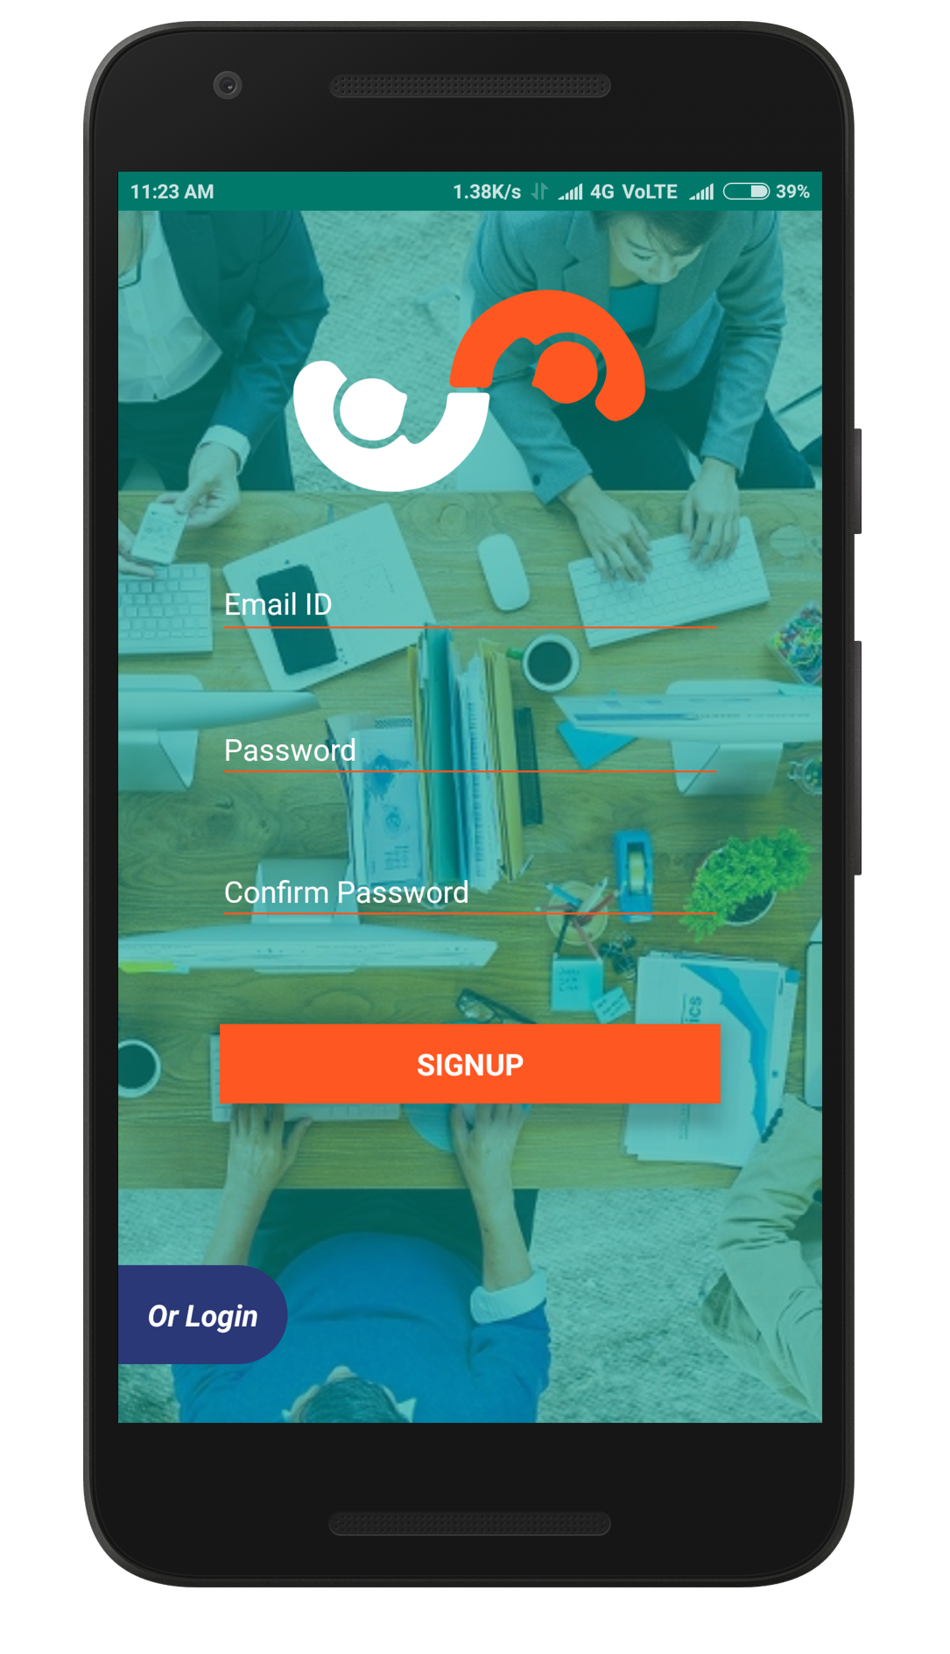

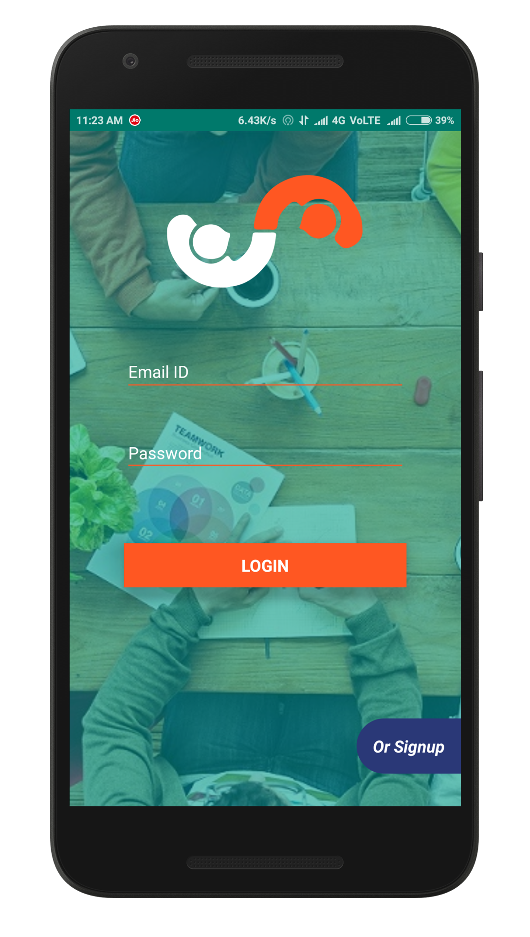

**Project flow**

Candidate

Login

**4.**

[EditCandidateEducationalDetails](http://103.230.103.142/jobportalapp/job.asmx?op=EditCandidatePersonalDetails) / EditCandidatePersonalDetails

**6.**

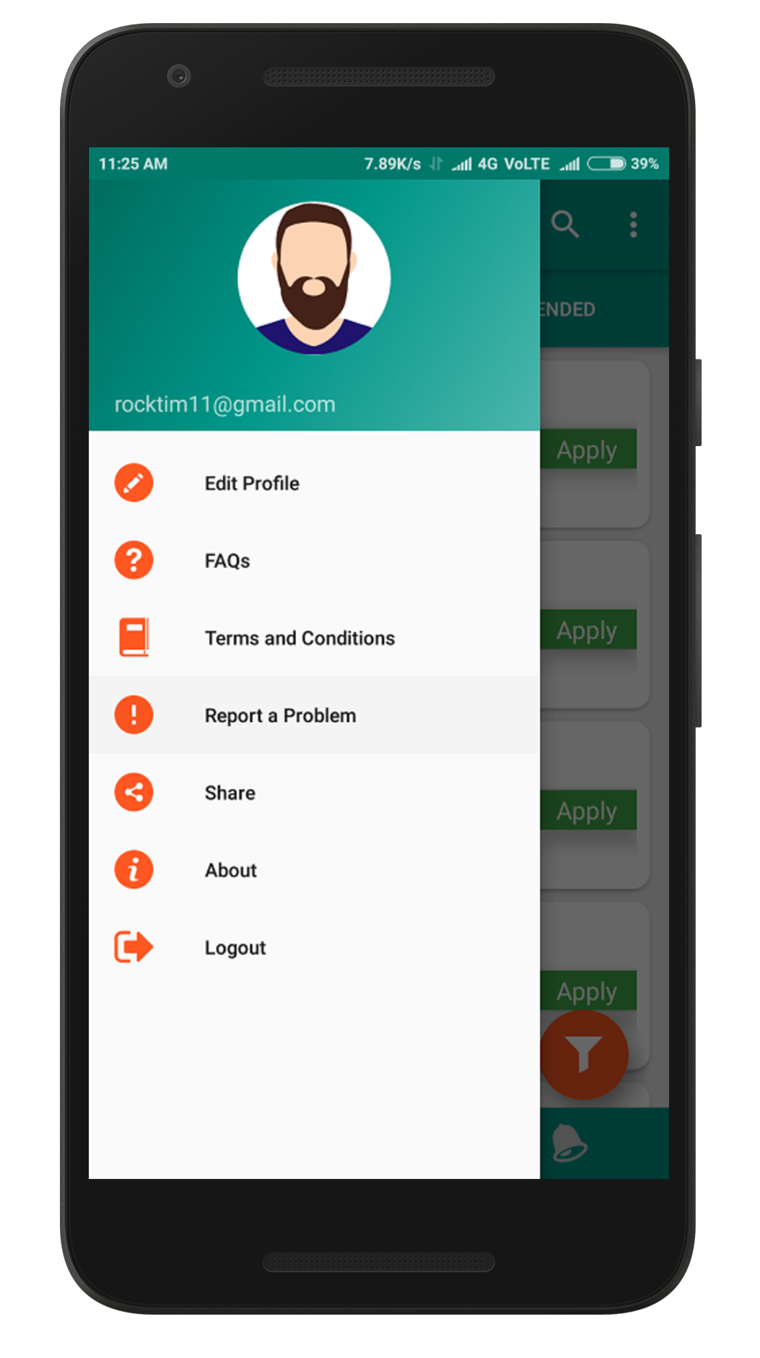

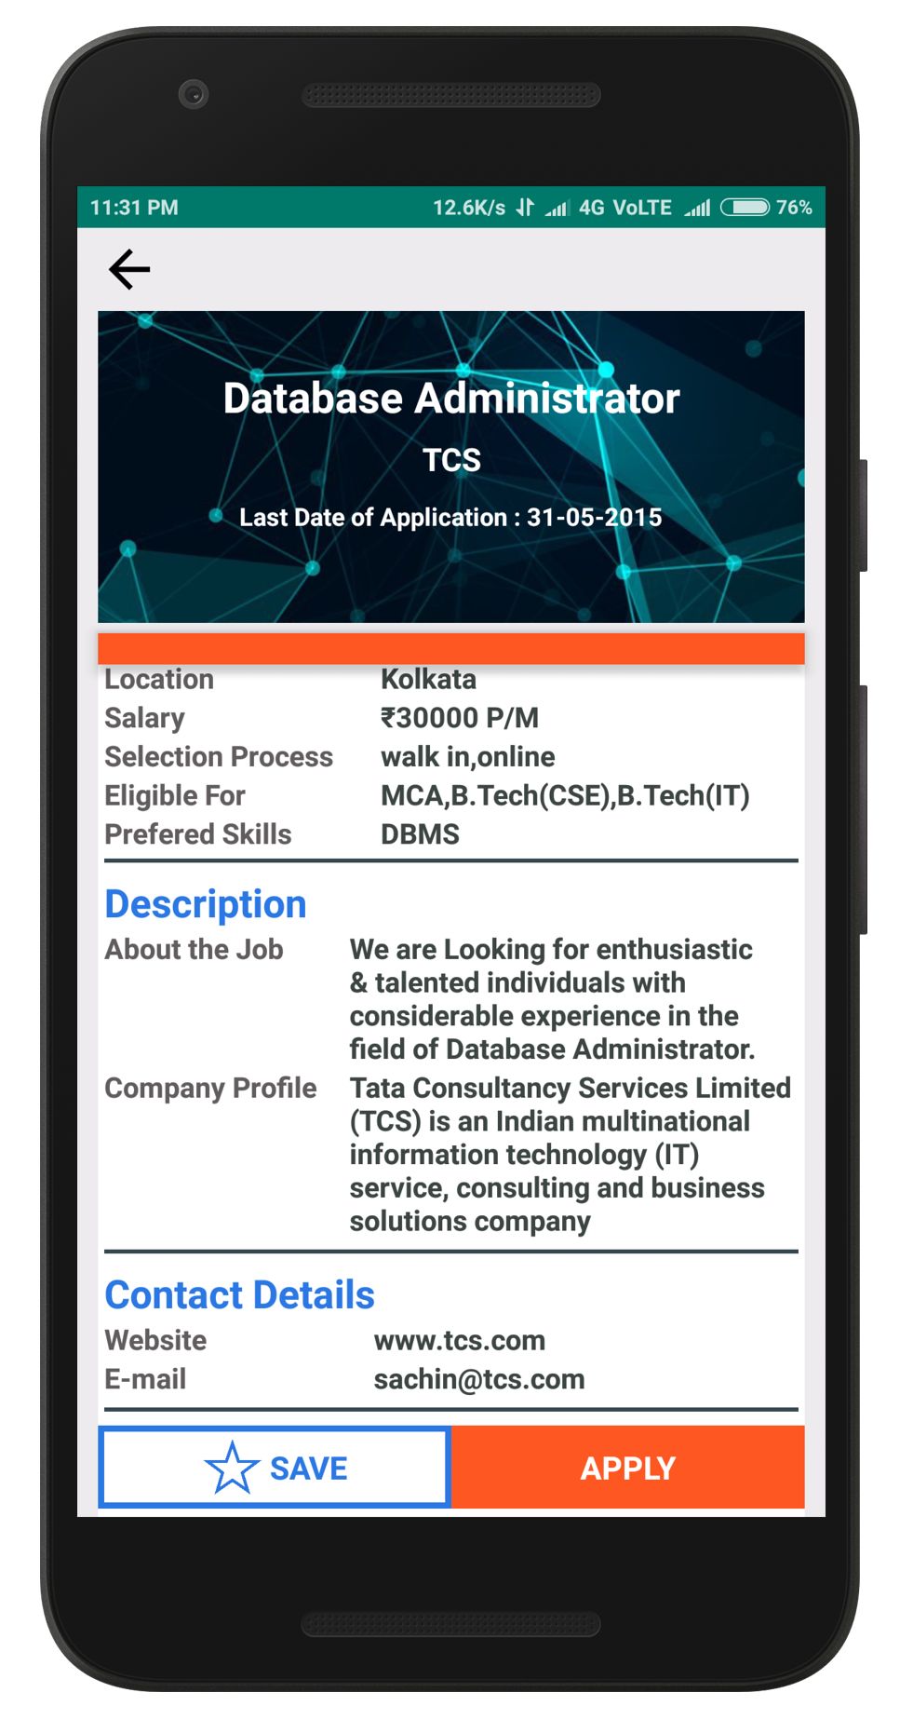

ApplyJob

Click on Job

Job Showing According

to Course Selected

Show All Job

Job According to Title

Job According to Skill

Job According to Company

Job According to Location

**5.**

[Job](http://103.230.103.142/jobportalapp/job.asmx?op=EditCandidatePersonalDetails)Search

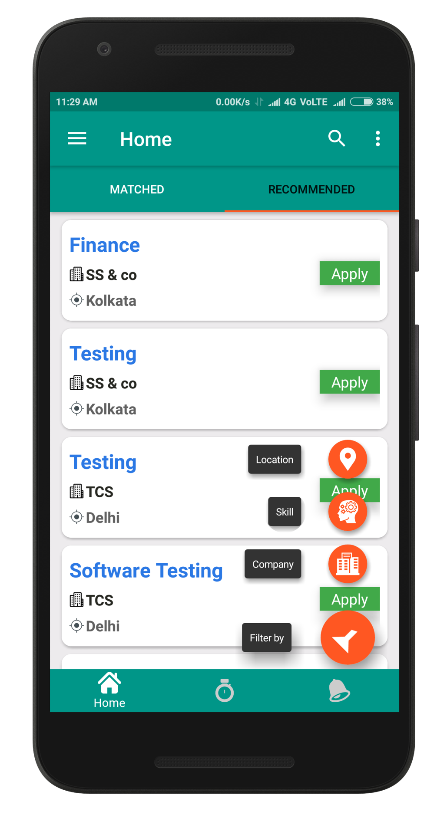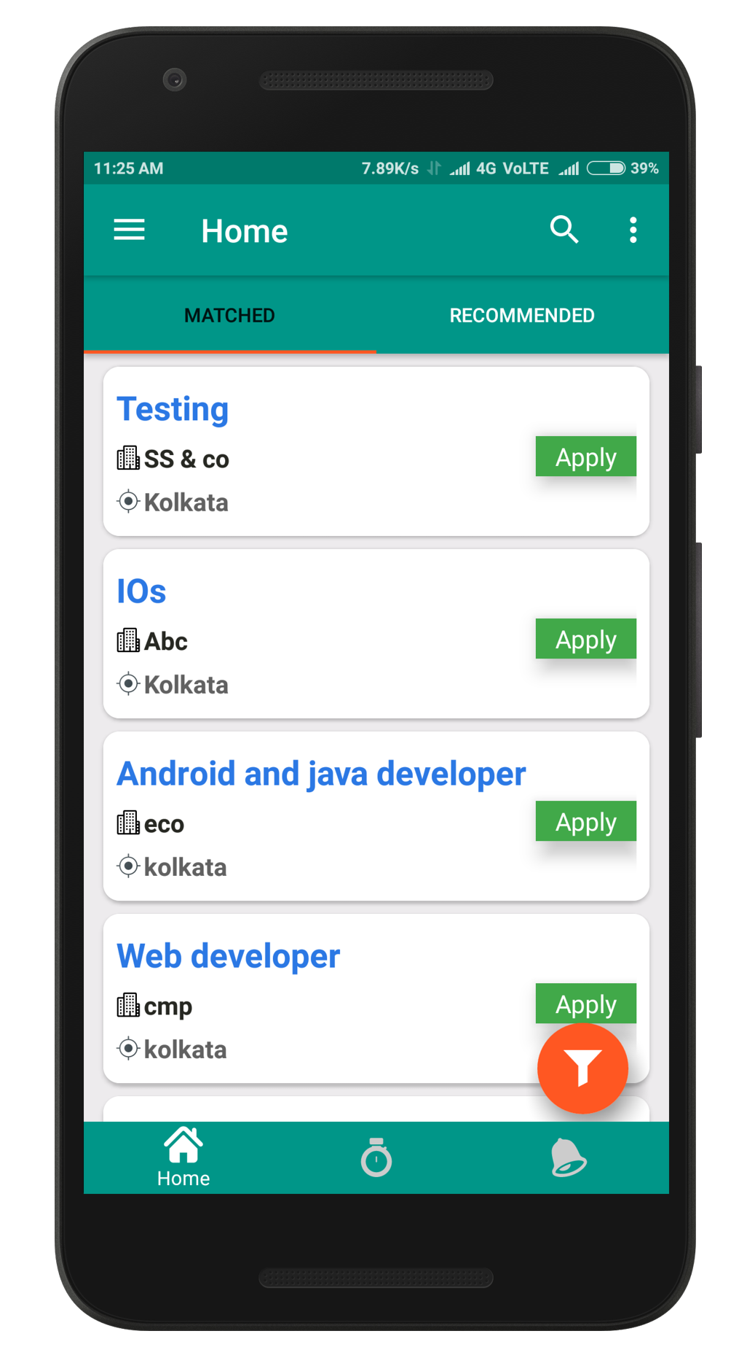

**7.**

Get[Job](http://103.230.103.142/jobportalapp/job.asmx?op=EditCandidatePersonalDetails)Details

**8.**

GetResponse / ViewJobResponse

